Fungifama
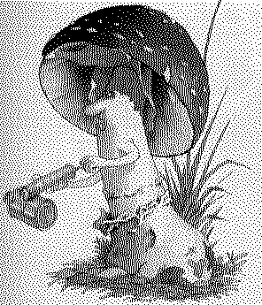

The Newsletter of the South Vancouver Island Mycological Society
August 2006

Introducing the SVIMS Executive for 2006
President
Christian Freidinger laurana@allstream.net
250-721-1793
Vice President
Gerald Loiselle. LoiselleG@telus.net
Treasurer
Chris Shepard scs@islandnet.com
Membership
Chris Shepard sos@islandnet.com
Secretary (interim)
Joyce Lee joleebc@lycos.com
250-656-3117
Foray Organizers
Adolf and Oluna Ceska aceska@victoria.tc.ca
250-477-1211
Jack and Neil Greenwell j.greenwell@shawlink.ca
Fungifama Editors
Heather Leary hleary@shaw.ca
250-385-2285
Shannon Berch shannonberch@telus.net
250-652-5201
Publicity & Library Manager
Joyce Lee joleebc@lycos.com

Webmaster
Ian Gibson ig@islandnet.com
250-384-6002
Directors at large
Kevin Trim kevintrim@shaw.ca
250-642-5953
Richard Winder sidewinder@spamcop.net
250-642-7528
Rob Gemmell Matrix_Azaleph@hotmail.com

Refreshments Organizers
Gerald and Marlee Loiselle loiselleG@telus.net
250-474-4344
Marcie Gauntlet marcichka@telus.net
SVIMS list serve master
Adolf Ceska adolf@victoria.tc.ca
To broadcast a message to SVIMS members via email: svims-l@victoria.tc.ca
SVIMS web site: www.svims.ca

Dues: $20.00 per year per household, payable in January by cheque made out to SVIMS or by cash at meeting.
Meetings: First Thursday of the month (no meetings December, January, July, and August), 7:00 p.m. sharp at the Pacific Forestry Centre, 506 Burnside Rd W, Victoria. Lots of free parking. The meeting room is near the main entrance door. Non-members welcome.

Monthly Meetings:

Sept 7: An Introduction to Fall Mushrooms by John Dennis, SVIMS, Victoria BC

Oct 5: Mushrooms and their Habitats in the Amazon Jungle of Brazil by Jean Johnson, SVIMS, Victoria BC and Mushroom Madness

Nov 2: Mushroom Identification DVD by Taylor Lockwood and Elections.
Visit: www.fungiphoto.com/Treasurechest/MIT/mit

 Richard's Morels Draw contributed $36 to the club’s finances.

Prez Sez
By Christian Freidinger
A question, which comes up regularly, concerns the ecological damage of collecting mushrooms. The mushrooms collected are fruiting bodies supporting the spores; the actual organism is the mycelium in the ground or in a host.
Is there a danger of damaging the propagation of new mycelia when a proportion of spores is removed by us?
Most mycelia of the mushrooms we collect have a long life-span and sometimes impressive dimensions (up to 10s of square miles). A considerable proportion of fruiting bodies are not collected and the number of spores is huge. So it seems that a) the habitat has to be large enough to support several genetically distinct mycelia and b) no detrimental changes to the environmental conditions should occur (water quality/table, plant cover/diversity, climate rain/wind, pollution).
Most mycologists support that environmental change and not a modest collecting threaten chanterelles and boletes.
If one species overextends and destroys another specie’s habitat, mostly its own survival will be at risk as well. These 'thrive and die-off" cycles occur quite often in nature. Humans having an aware mind and a conscious will to survive avoid those thrive/die-off cycles. All cultures developed some kind of environmental and social policy, ethics and customs to deal with over-fishing, over-hunting, depletion of soil, environmental pollution, etc. Historically the outcome was quite different as presented recently by Jared Diamond (1). To take from nature the 'smart way', thinking of tomorrow's dinner, is called sustainable management of resources. The extraction rate has to be equal in the long-term to the growth rate of the resource. To take more in a limited environment - and the earth became limited due to modern humans' large-scale actions - is creating an environment which is fundamentally different in its conditions from those times when humans did not have such a huge impact. Therefore the extraction of plants, animals and materials from nature implies a responsibility for this 'resource', i.e. for the survival of the affected species and their gene pool. An obligation? Maybe, but primarily it is in our very own best interest to control our own civilizations (the whole world is a suburb with parks of all kinds) because to evolve to those rapidly changed conditions would take millennia.
I hope you had an enjoyable summer somewhere between the ocean, the forest and the sky.
We all are very much invited to this fall's program and forays.
(1) Jared Diamond , Collapse How Societies Choose to Fall or Succeed, 2005

LOCAL EVENTS AND FORAYS:

SVIMS Annual Fall Foray
- Oct. 13, 14, 15, 2006
- Organized by Jack and Neil Greenwell
- Lake Cowichan Education Centre
- $83 per person, room and board for Friday night, Saturday and breakfast Sunday

Swan Lake Mushroom Show
- October 29, 2006
- Swan Lake Nature Centre
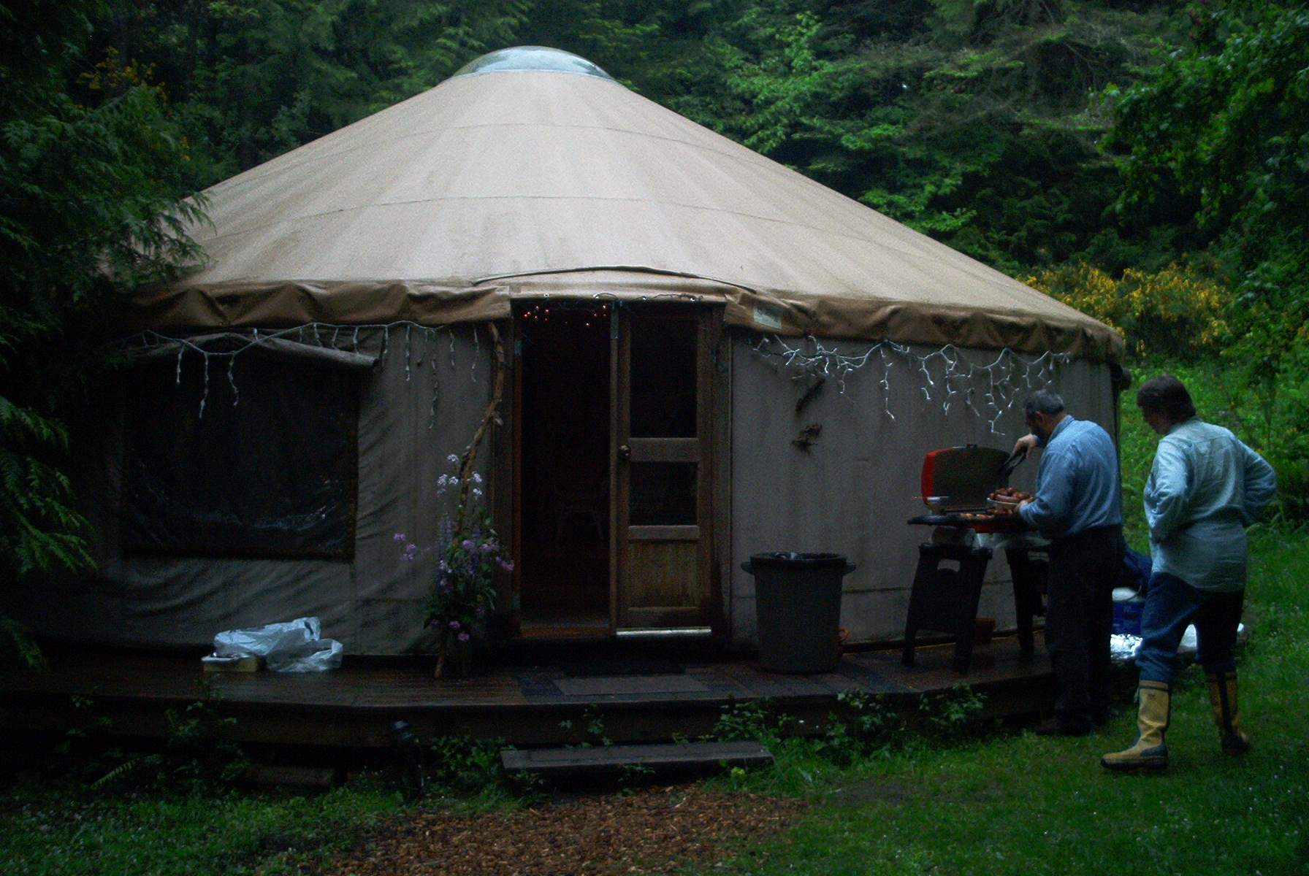
A rainy day brought a small but enthusiastic crowd for the SVIMS annual picnic.

FAR AWAY EVENTS AND FORAYS:

Manning Park Foray

September 8 – 10, 2006
- Vancouver Mycological Society
- http://www.vanmyco.com/

Sicamous & Shuswap Lake Wild Mushroom & Food Festival
- September 18 - 24, 2006
- Needed: mushroom guides for tours
- For more information or to volunteer, call
- 250-836-2220
www.shuswaplakemushroomfestival.com/

Newfoundland & Labrador Foray – Sept. 15-17, 2006 – Avalon Peninsula
- Forays of 6-10 people will be conducted in various provincial and federal parks. Early registrants get a discount and are assigned more desirable accommodations.
- Faculty: Michael Burzynski, Dave Malloch, Faye Murrin, Ron Peterson, Stan Pieda, Greg Thorn, Andrus Voitk, Gary Warren.
- For more information check the website at: www.hnhs.ca/mushrooms.

7th Annual Yachats Village Mushroom Fest

October 20 - 22, 2006
- Yachats, Oregon, USA
- Phone 541-547-3530 or 800-929-0477
- Fax +01-931-964-2200
- www.yachats.org/events.html

OTHER MYCOLOGICAL EVENTS:

Cowichan Salmon/Mushroom Festival
- October 28 & 29, 2006
- Organized by Ingeborg Woodsworth
- MayoCreekGardens@shaw.ca

INTERESTING MYCOLOGICAL WEB SITES

- Puget Sound Mycological Society
- www.psms.org/edibility.html
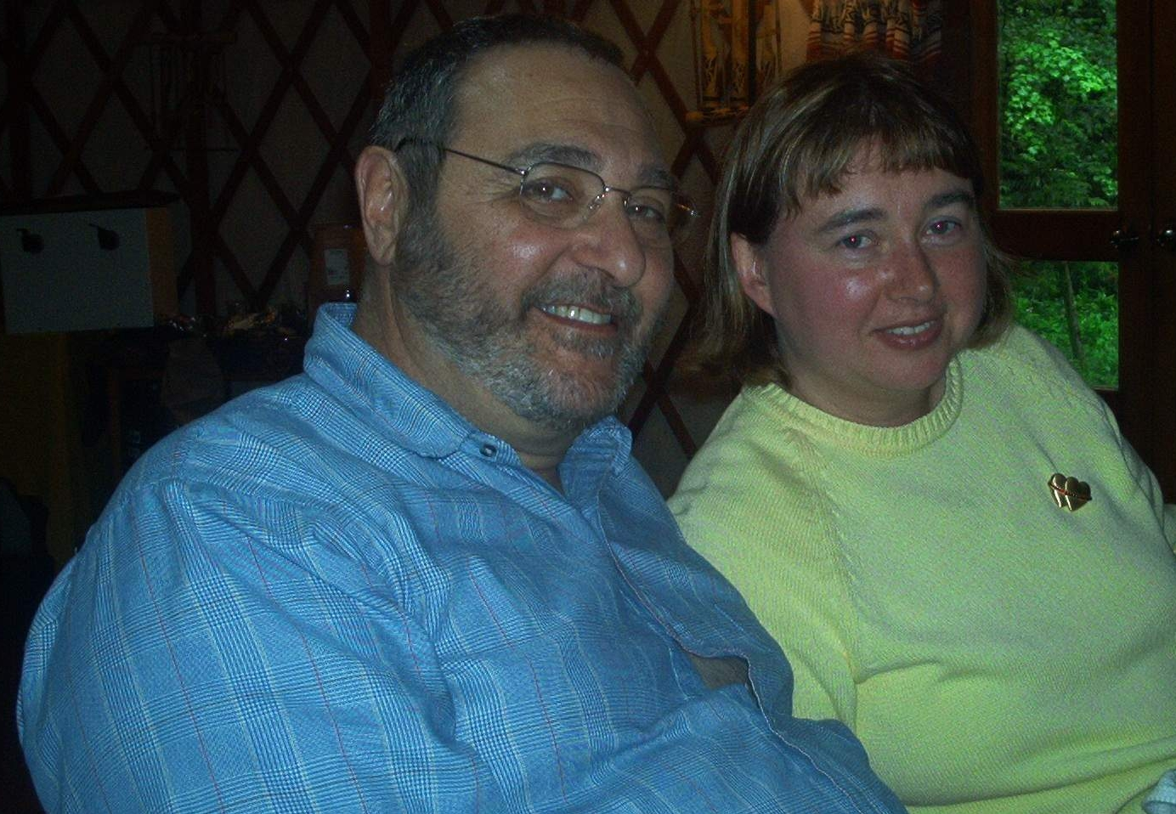
John Dennis and Renata Outerbridge celebrated their wedding anniversary with friends at the SVIMS picnic!

ARTICLES OF INTEREST

Reflections on Mushroom Poisoning – Part II. By Michael Beug. From his presentation at the March SVIMS meeting.
- Galerina autumnalis (9 people poisoned). Mistaken for the Honey Mushroom and for hallucinogenic mushrooms. No deaths in the data base but deaths have occurred and nursing infants have been poisoned. Contains Amatoxins in potentially lethal amounts. Liver damage in 60% of reported cases.
- Lepiota sp. (3 people poisoned) Many small members of the Lepiota genus contain potentially lethal amounts of Amatoxins. There are two reported poisonings by Lepiota josserandii in New York and one in BC by Lepiota subincarnata. All have resulted in liver damage and 2/3 resulted in death. Also lethal in dogs, as are the Destroying Angel mushrooms. It is a good practice not to eat any small wild mushrooms.
- Paxillus involutus (3 people poisoned) is also noted for causing kidney failure. A person in Oregon was poisoned and 2 in Washington over the past 30 years. Many people eat this mushroom without ill effect, but I recommend against this practice. The unknown toxin seems to be cumulative. No deaths have been reported in North America
- Boletus pulcherrimus caused a death in Oregon and the other person who consumed the mushrooms also was quite ill. Boletus satanas (4 people poisoned) is another red-tubed Bolete with a high probability of causing gastro-intestinal distress.
- Cortinarius in the cinnamomea group. Cortinarius is a huge genus with 1,000 to 2,000 species in North America, including a large number of big meaty mushrooms. I had anticipated seeing many poisonings from this group but in over 30 years of collecting data, only three mild incidents of poisoning by a Cortinarius species have been reported. One smallish non-descript brown member of the genus contains orellanine, a deadly toxin with a very long latent period, but while several deaths have been reported from this toxin in Europe, no poisonings have been reported from North America. Orellanine can be detected by a very strong turquoise or blue fluorescence under UV light. Both the mushroom and biopsy tissues will exhibit the fluorescence.
- Russula densifolia (1 person poisoned by R. nigricans). Some of the blackening Russulas can cause gastrointestinal distress, disorientation and convulsions. Russula subnigricans, a blackening Russula found in Japan is deadly poisonous.
- Russula emetica group (24 people poisoned from all Russula species combined). Some of the Russula species, notably but not exclusively the hot tasting ones, can cause pretty severe gastrointestinal distress and can even cause internal bleeding.
- Pleurocybella porrigens. Though there are no reported poisonings in North America, in the summer of 2004, Angel Wings, Pleurocybella porrigens, caused more than a dozen fatalities in Japan and sickened around 50 people. There was no GI distress. The onset was tremor and weakness of the extremities lasting 2-11 days followed by severe consciousness disturbance and intractable seizures. Deaths occurred one week to 1 month after symptoms began. The vast majority of affected individuals had been on kidney dialysis or had previously impaired kidneys and the average age was around 70. Known as Sugihirtake, Pleurocybella porrigens is a popular edible in Japan. September and October of 2004 saw a huge fruiting of the mushrooms and people consumed a lot more than normal. Avoid consumption of Angel Wings, especially if you have compromised kidneys. Always consume mushrooms in moderation.
- Inocybe geophylla var. lilacina (4 people poisoned from all Inocybe species combined). This mushroom, like most members of the huge Inocybe genus, is laced with muscarine. Surprisingly, in thirty years we have only gathered 2 reports of human poisoning by Inocybe species. Symptoms in addition to cramps, vomiting and diarrhea are perspiration, salivation and tears. Your pupils shrink to pinpoints. Inocybe species can be lethal to dogs that are probably attracted by the somewhat fishy odor of many species. Since they are small brown mushrooms they probably do not appeal to people looking for a meal, thus saving many cases of poisoning.
- Psilocybe baeocystis (62 people poisoned from all Psilocybe species combined) is just one of over a dozen hallucinogenic species found in the Pacific Northwest. The active ingredient of these mushrooms is psilocybin and psilocin. It grows readily in bark-mulched flowerbeds in maritime areas. Possessing mushrooms containing psilocybin or psilocin in the U.S. is treated the same as possession of heroin or cocaine.
- Psilocybe cyanescens is a very potent species containing over 1% hallucinogenic material. It also grows in bark-mulched beds in maritime areas. People consume these mushrooms intentionally for the hallucinations they can produce. Sometimes the effect is nightmarish instead of being pleasant. Many years ago a young Oregon child died from grazing on this mushroom.
- Psilocybe cubensis grows naturally in subtropical regions and is readily cultivated. It rarely has more than 0.4% psilocybin and psilocin and is highly variable in potency. The only death that I am aware of from this mushroom was a due to anaphylactic shock – an extreme food allergy to this species.
- Psilocybe semilanceata, the liberty cap, grows in marshy pastures and is a very steady 1.6 to 1.7% psilocybin. At low doses any of these species can cause uncontrolled hilarity. At higher doses hallucinations can be encountered, typically lasting 6 hours. Some people lose muscular control for several hours and so consuming these mushrooms out in the cold and rain can be disastrous. With any of the mushrooms containing psilocybin or psilocin, some individuals can suffer one or more of the following: severe gastrointestinal distress, convulsions, hypotension, dermatitis, extreme anxiety, agitation, paranoia, muscle spasms, mydriasis, atrial fibrillation, kidney failure, liver damage, suicidal tendencies, angiodema, blurred vision, flushing, tight chest, ataxia, tachycardia, dry mouth.
- In the Northwest, Panaeolus foenisecii (18 people poisoned) is normally inactive. It grows abundantly in lawns in the summer throughout North America. It is one of the most common mushrooms gathered by young children. Usually they are unaffected, but sometimes they consume some that contain enough psilocybin to cause hallucinations. Other effects in children can include gastrointestinal distress, fever, flushing, disorientation, drowsiness or insomnia, hives and dermatitis, loss of consciousness
- Conocybe cyanopus is another hallucinogenic species of the Northwest but consumption of this one is particularly dangerous because of the close similarity to deadly Pholiotina filaris or Galerina species.
- Pluteus washingtonensis is a hallucinogenic species that could easily be picked by a person seeking the Deer Mushroom, Pluteus cervinus.
- Gymnopilus ventricosus (16 people poisoned by G. spectabilis) occurs in the Northwest and the samples I have analyzed have all lacked hallucinogenic content. However, an exact look-alike, Gymnopilus spectabilis, occurs in Japan and in Eastern North America. It is known as the “big laughing mushroom” and is a potent, though very bitter hallucinogen.
- Gymnopilus luteofolius is a Northwest Gymnopilus that contains psilocybin. It is so intensely bitter that I do not know how anyone could choke it down in trying to get high.
- Gyromitra esculenta (27 people poisoned) has the common name of “Beefsteak Morel” and is a species that I used to cook outdoors and eat. I cooked it outdoors because the toxin, Gyromitrin decomposes on heating and the resultant deadly hydrazine vaporizes between 70 and 80 degrees C. I quit eating it and serving it to my classes many years ago. Poisonings by various Gyromitra, Helvella and Verpa species account for about 4% of all poisoning cases. The most serious concern is that of the people who suffer gastric distress from Gyromitra esculenta, 1/3 also suffer liver damage and 11% suffer kidney failure.
- Verpa bohemica (9 people poisoned) is considered poisonous capable of causing gastrointestinal distress, loss of muscular coordination and a wide range of other unpleasant side effects. However, there are only 7 reports of poisoning in the NAMA database and the mushroom is picked and sold commercially so a lot of people eat it each year without becoming ill.
Bamfield mushroom festival
We need your help! We are planning to publish a mushroom cookbook as a fundraiser for our annual Bamfield mushroom festival. We are asking for recipe contributions from people who have been to or wish they had been to our festival. Send your favourite mushroom based recipes to Janet at tyeejan@island.net or Brunhilde at wcm@alberni.net. Your name, hometown and fun comments will be printed together with the recipe in the book if that's okay.
Thanks for your help,
Mushroom Jim

A Mushroom Hunting Checklist
Courtesy of Oregon Mycological Society
When you take to the wilds in search of mushrooms, be prepared! Here is a checklist for the well-equipped mushroom hunter:

On Your Body
- Polyester or wool clothes
- Rain jacket
- Rain pants
- Gaters
- Sturdy moisture-proof boots
- Hat - appropriate for conditions
- Mittens/gloves
- Wristwatch
- Compass
- Hand lens
- Whistle
- FRS walkie-talkie radios (optional)
- GPS (optional)

In Your Flat-Bottomed Basket
- Waxed paper bags
- Knife, brightly marked
- Brown paper bags

In Your Knapsack
- Good map of the area
- Lunch
- Water
- Extra Clothes
- Sunscreen
- Insect repellent
- Trowel and Toilet Paper
- Field guides and key
- Notebook & pencil
- Spore print making equipment (black and white paper)
- Photography equipment
- Emergency blanket
- First Aid Kit
- Matches (waterproof)
Library Update
- At SVIMS meetings there will be a list of books available for members in good standing to review.
- Members can then request the item for the next meeting. Loan period to be until the next meeting.
- SVIMS Library needs you to donate items to expand the library. Bring donations to the Sept. 7 meeting.
- Also, volunteers needed at meetings to help with library.
- Please email Joyce at joleebc@lycos.com or phone 744-3644.

If you go down to the woods today...
Bryce Kendrick, originally published in Island Tides
In the words of the old saying, the logging companies and the Government apparently ‘can’t see the forest for the trees’.
This is certainly wilful blindness on their part. They have enough knowledgeable employees that it seems impossible for them to remain unaware of the true nature of the old-growth forests they are ‘harvesting’ so unsustainably.
What is a forest? To some people (forest company executives?) it is just a collection of trees: two-by-fours in waiting, wood on the hoof, and in the case of old-growth forests, a collection that includes many dead and dying trees which, if not ‘harvested’ will merely rot away. What a waste.
In truth, every true forest (and I’m not speaking of the biotically impoverished plantations that are often deliberately created after first-growth forests have been removed) is a rich and complex community of living organisms, not tens or hundreds, but thousands of different species, ranging in size from the trees, all the way down to bacteria less than 1/25,000th of an inch long. And as the size of member species decreases, the number of individuals usually increases, until we discover that there are scores of birds, thousands of smaller plants, untold millions of bacteria, for every single tree.
E. O. Wilson writes: ‘Eliminate just one kind of tree...and some of its pollinators, leafeaters and woodborers will disappear with it, then various of their parasites and key predators, and perhaps a species of bird or bat that depends on its fruit - and when will the reverberations end?’ To this list I could add: its symbiotic mycorrhizal fungi, and other fungi that specialize in attacking or decomposing (recycling) its leaves and its wood, and a variety of specialized mycophagous (fungus-eating) invertebrates.
Old-growth cutting in southwestern B.C. is now being blamed for declines in populations of 17 species of mammals, birds, amphibians and fish. And the bird species, such as the spotted owl, coastal marbled murrelets, and northern goshawks, are only the larger and more conspicuous members of the biota to be threatened with regional extinction. It is generally agreed that if the birds in a habitat are OK, then everything else is likely to be fine as well. So we can use the birds as our red flag, our indicator of danger, our ‘canary in the mine’ of the forest. Since they are obviously not OK in our coastal forests, almost everything else that lives in old-growth forests is also likely to be threatened by the destruction of their habitat. In many cases we can be reasonably confident that they are organisms (albeit small ones) that have not even been detected and described as yet by scientists. For example, it is clear that there are many more fungi out there than have yet been seen. One credible estimate for the whole Earth is 1,500,000 of which only about 100,000 - about 7% - have so far been described. However, despite their vital importance in almost every terrestrial ecosystem, as decomposers and root symbionts, most people find it hard to generate much enthusiasm for the fungi.
So let’s try a bird species. The spotted owl has never been common, but there used to be about 500 pairs in B.C., the only Province in which they occur. Largely as a direct result of the logging of old-growth forests, this population has now been reduced to 23 individuals, and in 2005 researchers could locate only 6 breeding pairs. This is clearly an ongoing disaster. And we are sadly much nearer the end of this process than the beginning.
To shift focus for a moment, the public is also aware that many of our salmon runs are in danger, and although some of that has to do with overfishing, and the vagaries of life in the open ocean, it is also clear that degradation of spawning habitat, caused in many cases by imprudent and unsustainable logging, often in riparian habitat, shares much of the blame.
We must ask if we can trust the forestry industry with our rare wildlife, but equally we must question our Provincial government, which is basically responsible to us, the electorate, for what is permitted to happen to the environment here. Are either of these groups really acting in a responsible manner, or is the bottom line the only thing that counts? It is well beyond time that Government act decisively in the interests of the communities of life inhabiting our forests.
To quote E.O. Wilson again: ‘...to the degree that we come to understand other organisms,
we will place a greater value on them, and on ourselves.’
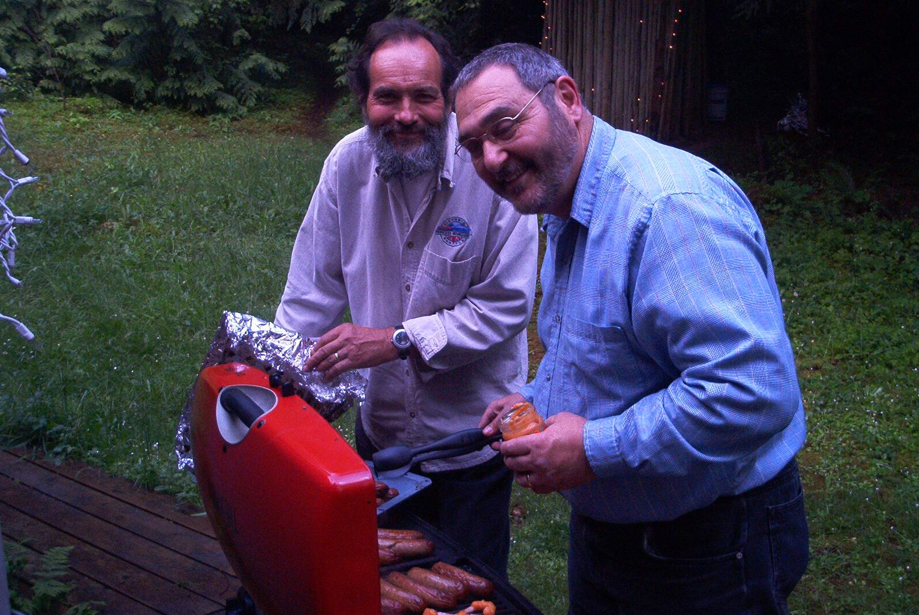
Christian and John barbecuing at the SVIMS picnic.

Mushrooms touted as vitamin D source
Made when crop given UV light: Study
Could offer unique source for nutrient
Toronto Star, Apr. 19, 2006

WASHINGTON — Mushrooms may soon emerge from the dark as an unlikely but significant source of vitamin D, the sunshine vitamin that helps keep bones strong and fights disease. New research, while preliminary, suggests that brief exposure to ultraviolet light can zap even the blandest and whitest farmed mushrooms with a giant serving of the vitamin. The Food and Drug Administration proposed the study, which is being funded by industry.
Exposing growing or just-picked mushrooms to UV light would be cheap and easy to do if it could mean turning the agricultural product into a unique source of vitamin D, scientists and growers said. That would be a boon especially for people who don't eat fish or milk, today the major fortified source of the vitamin.
One grower predicted the pilot project, if supported by further research, could give consumers a radically different reason to buy mushrooms, now prized for being low in fat and calories.
"They eat them for what they don't have, versus what they do have," said Joe Caldwell, vice-president of Monterey Mushrooms. The Watsonville, Calif., company is the nation's largest producer of fresh mushrooms.
The ongoing work so far has found that a single serving of white button mushrooms — the most commonly sold mushroom — will contain 869 per cent of the daily value of vitamin D when exposed to just five minutes of UV light after being harvested. If confirmed, that would be more than what's in two tablespoons of cod liver oil, one of the richest — and most detested — natural sources of the vitamin, according to the National Institutes of Health.
Details were being presented this week at the FDA's annual science forum. The FDA proposed the research, which was funded by the Mushroom Council, as the agency looks for ways to increase the amounts of vitamin D consumed by Americans.
"This could be it," said Robert Beelman, a Penn State food scientist who's spent more than a decade working to give mushrooms their own "nutritional identity.''
Sunshine is a significant source of vitamin D, since natural UV rays trigger vitamin D synthesis in the skin. Mushrooms also synthesize vitamin D, albeit in a different form, through UV exposure. Growers typically raise the mushrooms indoors in the dark, switching on fluorescent lights only at harvest time. That means they now contain negligible amounts of vitamin D.
Research, including new findings also being presented at the conference, consistently has shown that many adult Americans do not spend enough time outside to receive enough UV exposure needed to produce ample vitamin D. The problem is especially acute in winter.
The widespread use of sunscreen is also contributing to vitamin D deficiency; sunblock with an SPF factor of 8 or greater can block out 90 per cent or more of the UVB rays.
That worries health officials and not only because of rickets, the soft-bone disease linked to vitamin D deficiency that was a scourge in decades past. Vitamin D is increasingly thought to play a role in reducing the risk of osteoporosis, cardiovascular disease and tooth loss, as well as in reducing mortality associated with colon, breast, prostate and other cancers.
In Memoriam

ADAM F. SZCZAWINSKI (1913-2006)

Adapted from: Turner, Nancy J. 2006. Adam F. Szczawinski, A Botanical Pioneer in British Columbia. Davidsonia (Upcoming issue.)

Adam Szczawinski was born on October 21, 1913 in Lwow, Poland. He attended the University of Lwow from 1932 to 1937, where he studied botany and medicine. In 1936, he became a lecturer in biology at the Commercial College in Lwow, and in 1937, an instructor at the University of Lwow, until 1939 when World War II broke out. He was forced to flee Poland and enlisted in the Polish Army in France on January 4, 1940. He fell in love with and married Mary, his beautiful Scottish wife, and together they emigrated to Canada in 1948.

He received his Ph.D. through the Department of Botany, at the University of British Columbia, in 1953. He was UBC's first PhD recipient in botany. After completing his PhD, he remained as a lecturer in the Department of Botany at UBC until 1955, when he took the position as Curator of Botany and Head of the Botany Division at the British Columbia Provincial Museum [now Royal British Columbia Museum] in Victoria. Mary gave birth to their only child, their son Alan, in 1956. Tragically, in 1968, when Alan was only 12 years old, Mary died suddenly from a heart attack; Adam never remarried.

Together with Dr. V. J. Krajina and others, he conceived and implemented the Ecological Reserves program in British Columbia. As well as recruiting authors for several of the handbooks, he personally authored and co-authored several of Handbooks as well as co-authoring the Flora of the Saanich Peninsula (with A. S. Harrison). After his retirement in 1975, he continued to give many public lectures, especially on edible mushrooms and co-authored five additional books.

Adam Szczawinski passed away peacefully at Victoria General Hospital on June 2, 2006. Until the time he entered the hospital, he lived in his own home, the one he and Mary had purchased when they moved to Victoria, on Viaduct Avenue. He is survived by his son, Alan Szczawinski, daugher-in-law Barbara Lund, and grandchildren Jacob, Maxwell and Kira.
Beelman said his research has shown that exposing growing mushrooms to three hours of artificial UV light increases their vitamin D content significantly.
The only drawback is that the white button mushrooms — like people — tend to darken with increased UV exposure, he added.
Have you got an interesting article, anecdote, poem, photograph or website to share? We’ll include it in Fungifama. Email your submission to hleary@shaw.ca.
Caution: The South Vancouver Island Mycological Society (SVIMS) newsletter, Fungifama, is not intended as an (online) identification or medicinal guide to mushrooms. There are risks involved in eating and in using wild mushrooms. The possibility may exist that you are allergic to a specific mushroom, or that the mushroom may be anomalous. SVIMS, Fungifama and the authors on this site warn that the reader must accept full personal responsibility for deciding to use or consume any particular specimen.

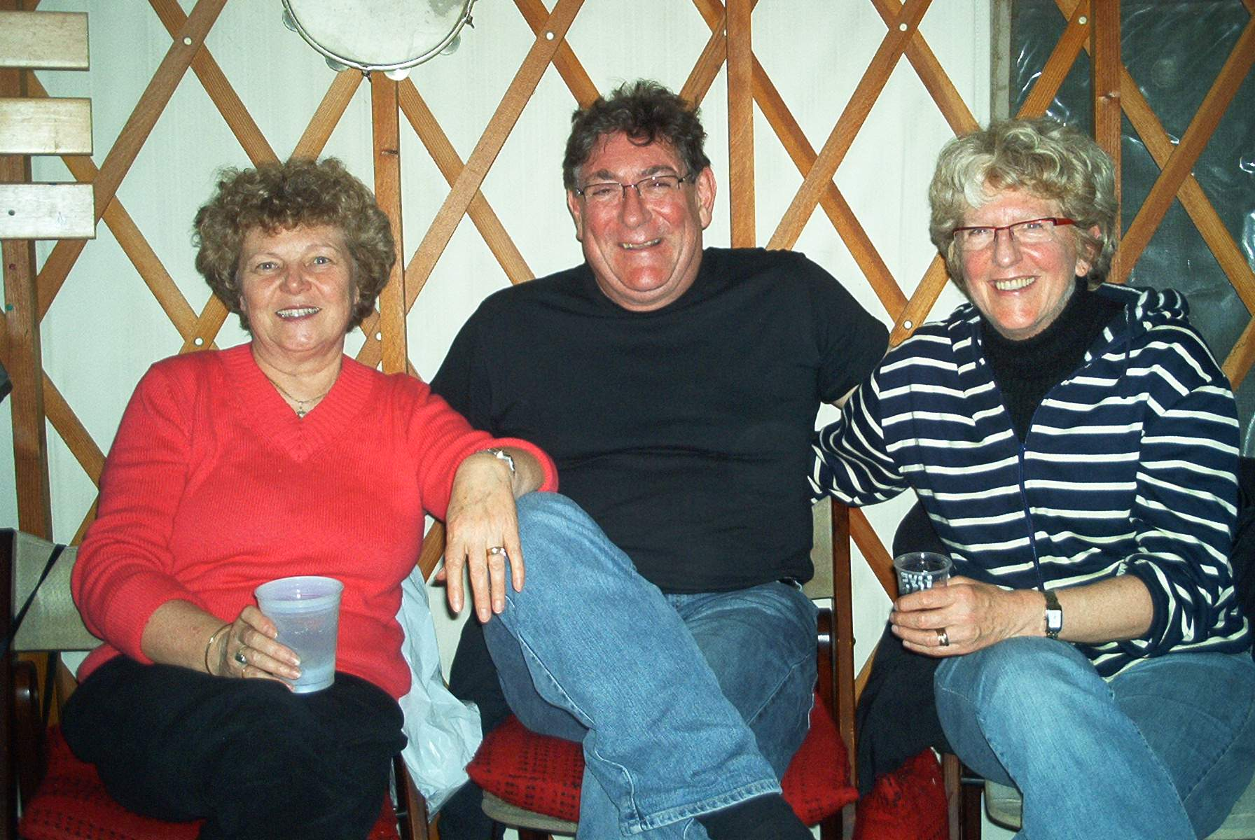
Swedish guests with Ann at the SVIMS annual picnic

Eminent North American mycologist, Orson K. Miller, Jr. passed away June 9, 2006.
http://www.ou.edu/cas/botany-micro/ben/ben364.html

